To make an invisible seam when joining garter stitch pieces end to end:

- With the right sides of your pieces facing upwards, put the pieces on a flat surface.

- With a yarn needle and matching color yarn, catch the V found between the first set of garter ridges as seen in the diagram below.
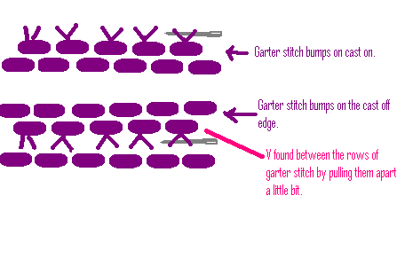
- Repeat step 2 on the bottom piece.
- Alternate between the two pieces gently pulling the yarn to close the seam as you go.

Your seam will look like this before you tighten it up:
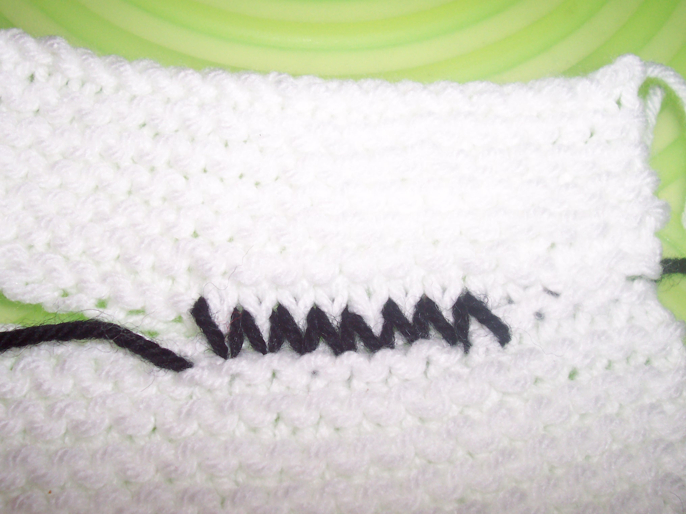

But then it will look like this:
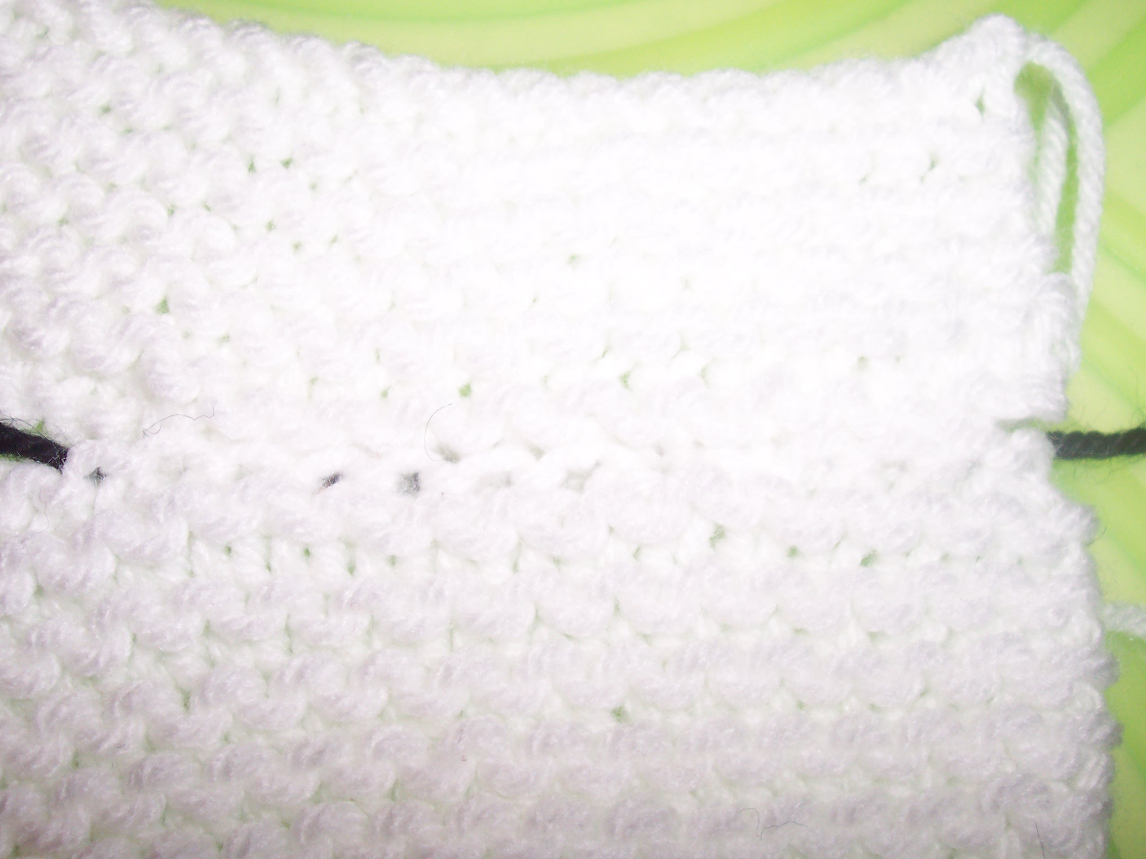
Can you find my seam?? Even with using black yarn, it’s invisible!

